# Supplemental Tables

Table 2: Summary of number fish, and number of sample events for each contaminant and species in the dataset used in this analysis. Values are listed as ‘train fish (train sample events) / test fish (test sample events)’ for each dataset.

| CONTAMINANT | SPECIES_NAME | SER | REML | boot_REML | MCMC | INLA |
| --- | --- | --- | --- | --- | --- | --- |
| As | Lake Trout | 65(10)/10(7) | 120(27)/10(7) | 120(27)/10(7) | 120(27)/10(7) | 120(27)/10(7) |
| As | Northern Pike | 156(19)/47(33) | 465(104)/50(35) | 465(104)/50(35) | 465(104)/50(35) | 465(104)/50(35) |
| As | Walleye | 152(21)/40(29) | 416(98)/43(30) | 416(98)/43(30) | 416(98)/43(30) | 416(98)/43(30) |
| Hg | Lake Trout | 4234(396)/558(312) | 6122(638)/559(313) | 6122(638)/559(313) | 6122(638)/559(313) | 6122(638)/559(313) |
| Hg | Northern Pike | 10095(1017)/1620(854) | 13870(1474)/1625(859) | 13870(1474)/1625(859) | 13870(1474)/1625(859) | 13870(1474)/1625(859) |
| Hg | Walleye | 14246(1172)/2551(1043) | 17931(1445)/2555(1047) | 17931(1445)/2555(1047) | 17931(1445)/2555(1047) | 17931(1445)/2555(1047) |

# Supplemental Figures

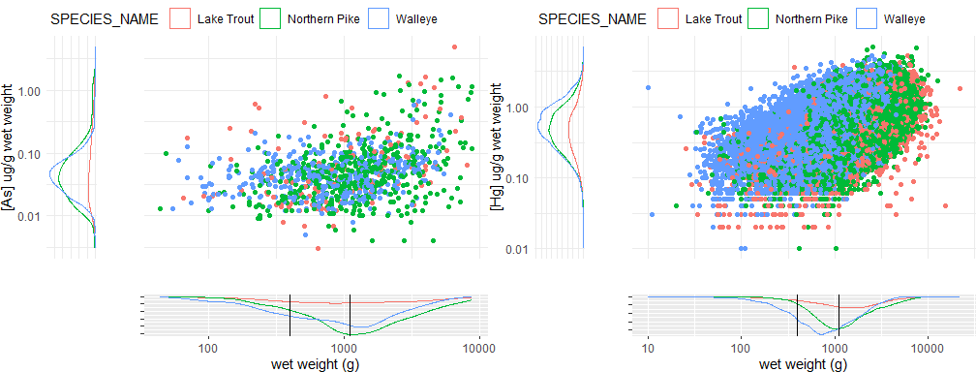

Figure S1: Number of fish at different body weights and contaminant concentrations for [As] and [Hg]. Vertical black lines show the weights that are commonly used for standardization.

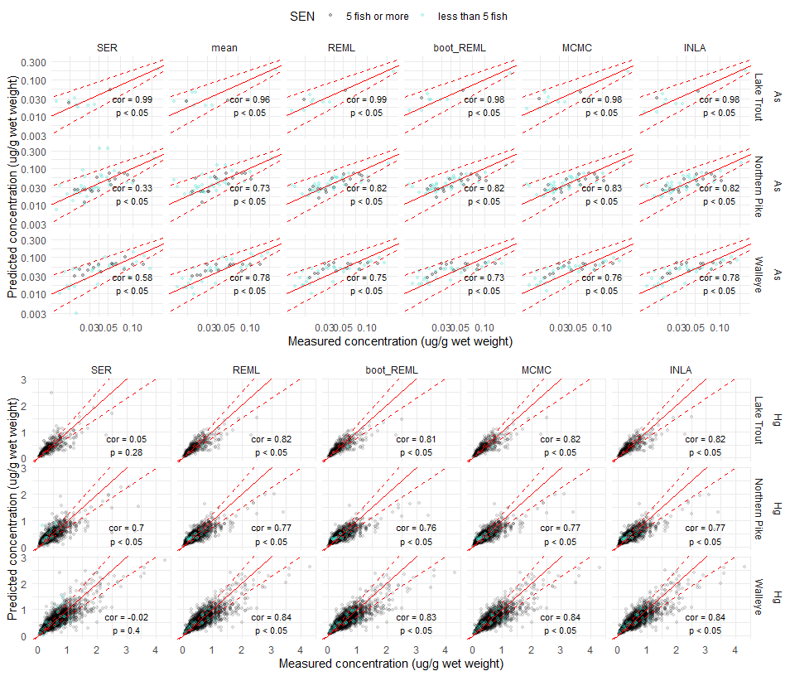

Figure S2: Predicted concentration of [As] and [Hg] in tissue of 400-600g and 900-1100g fish compared to measured values. Points display each individual fish prediction (with blue points representing predictions at sampling events with less than 5 fish, and black points representing predictions from sampling events with at least 5 fish) and a solid red line shows a 1-1 relationship. The dashed red lines provide an interval for predicted values that are within 25% of the measured value. Correlation statistics are included where there were enough values to compute them. Axes are shown on a log scale, as values were modelled from log-transformed values.

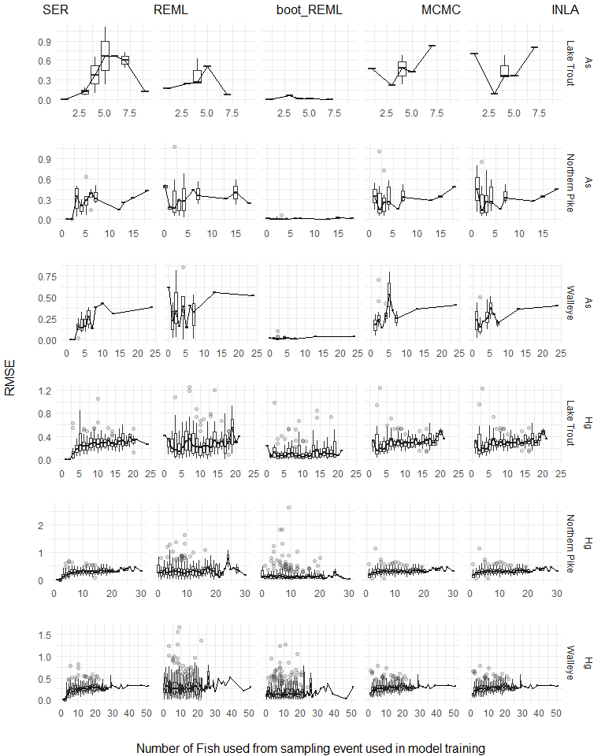

Figure S3: Root mean squared error (RMSE) of models from sampling events trained with different numbers of fish. RMSE of training set sampling events are compared to the number of fish used from the sampling event that were included in the training dataset. For each N, a boxplot displays the 25th and 75th percentiles and the median RMSE, with the whiskers extending out to 1.5 x the interquartile range. A line is plotted across the median values to show the overall trend in the values.

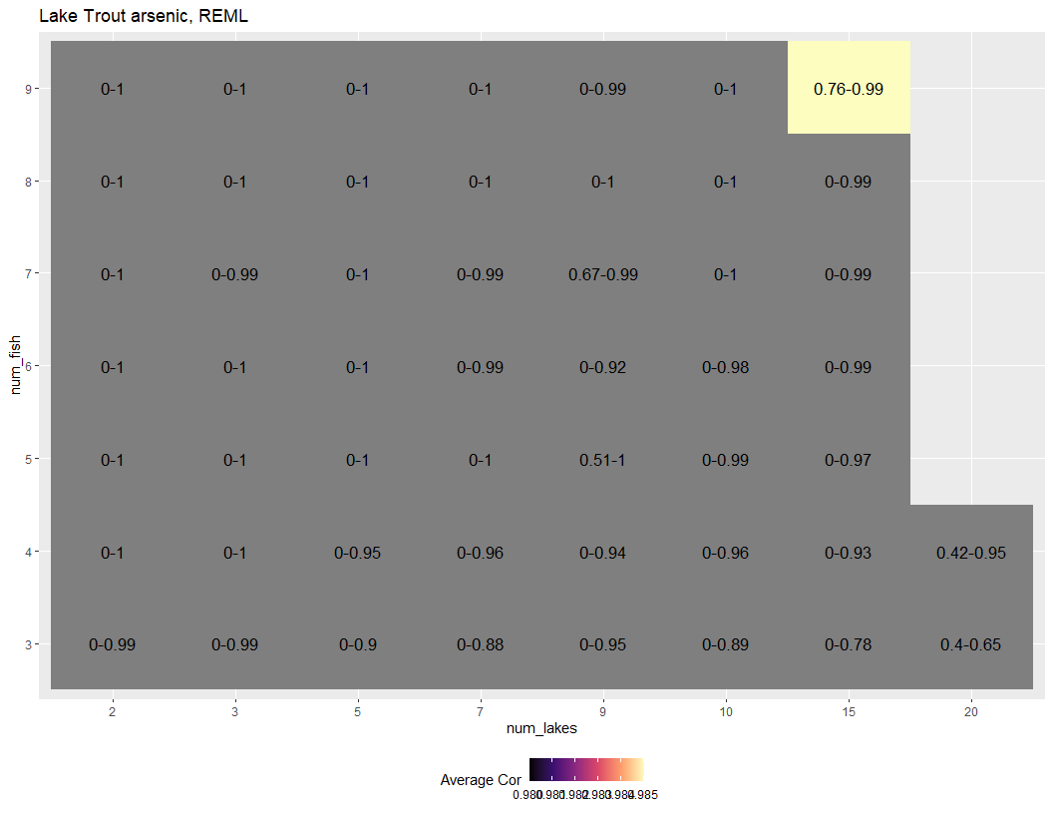

Figure S4: Range of Pearson correlation scores for simulated samplings of Lake Trout [As] REML predictions from different lake and fish number combinations. Combinations where there is inadequate performance (min correlation < 0.75 and max correlation <.8) and where performance is unstable when fish or lake numbers are increased are indicated in grey, while remaining cells are colored with light values representing better average model performance.

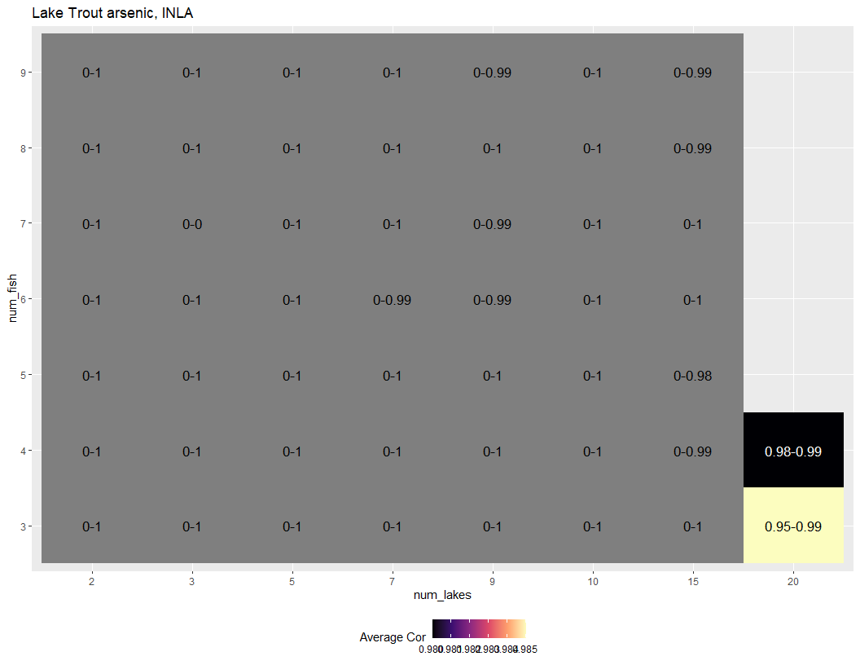

Figure S5: Range of Pearson correlation scores for simulated samplings of Lake Trout [As] INLA predictions from different lake and fish number combinations. Combinations where there is inadequate performance (min correlation < 0.75 and max correlation <.8) and where performance is unstable when fish or lake numbers are increased are indicated in grey, while remaining cells are colored with light values representing better average model performance.

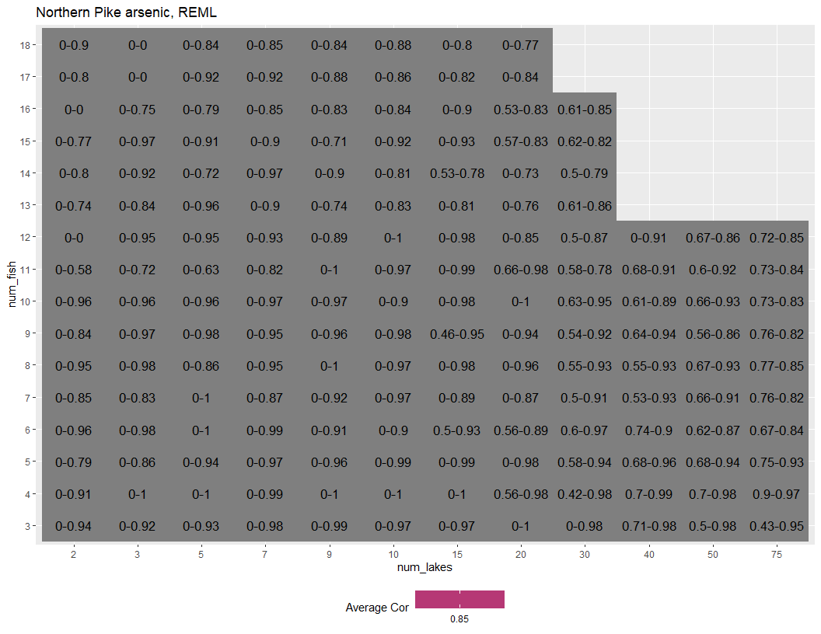

Figure S6: Range of Pearson correlation scores for simulated samplings of Northern Pike [As] REML predictions from different lake and fish number combinations. Combinations where there is inadequate performance (min correlation < 0.75 and max correlation <.8) and where performance is unstable when fish or lake numbers are increased are indicated in grey, while remaining cells are colored with light values representing better average model performance.

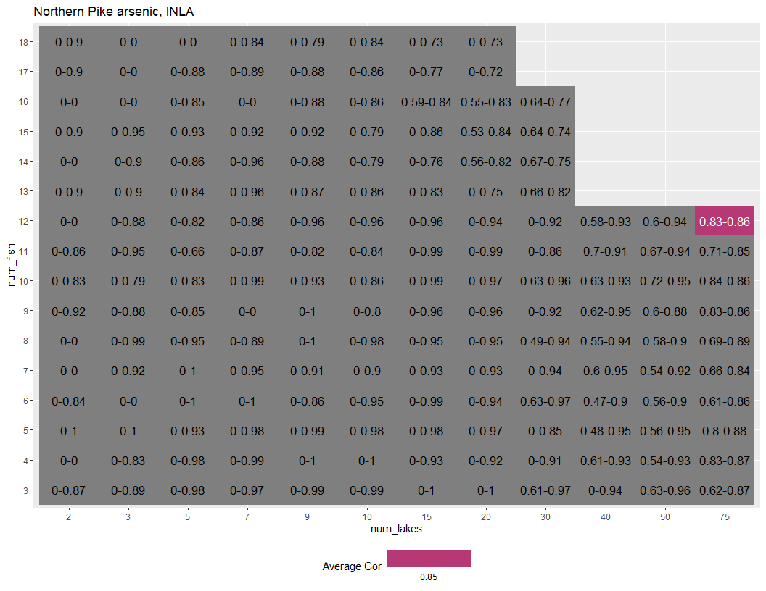

Figure S7: Range of Pearson correlation scores for simulated samplings of Northern Pike [As] INLA predictions from different lake and fish number combinations. Combinations where there is inadequate performance (min correlation < 0.75 and max correlation <.8) and where performance is unstable when fish or lake numbers are increased are indicated in grey, while remaining cells are colored with light values representing better average model performance.

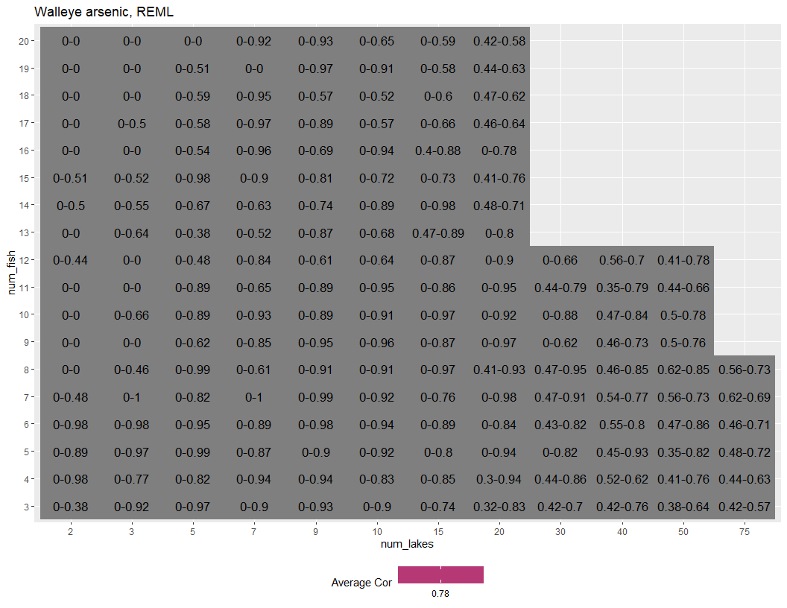

Figure S8: Range of Pearson correlation scores for simulated samplings of Walleye [As] REML predictions from different lake and fish number combinations. Combinations where there is inadequate performance (min correlation < 0.75 and max correlation <.8) and where performance is unstable when fish or lake numbers are increased are indicated in grey, while remaining cells are colored with light values representing better average model performance.

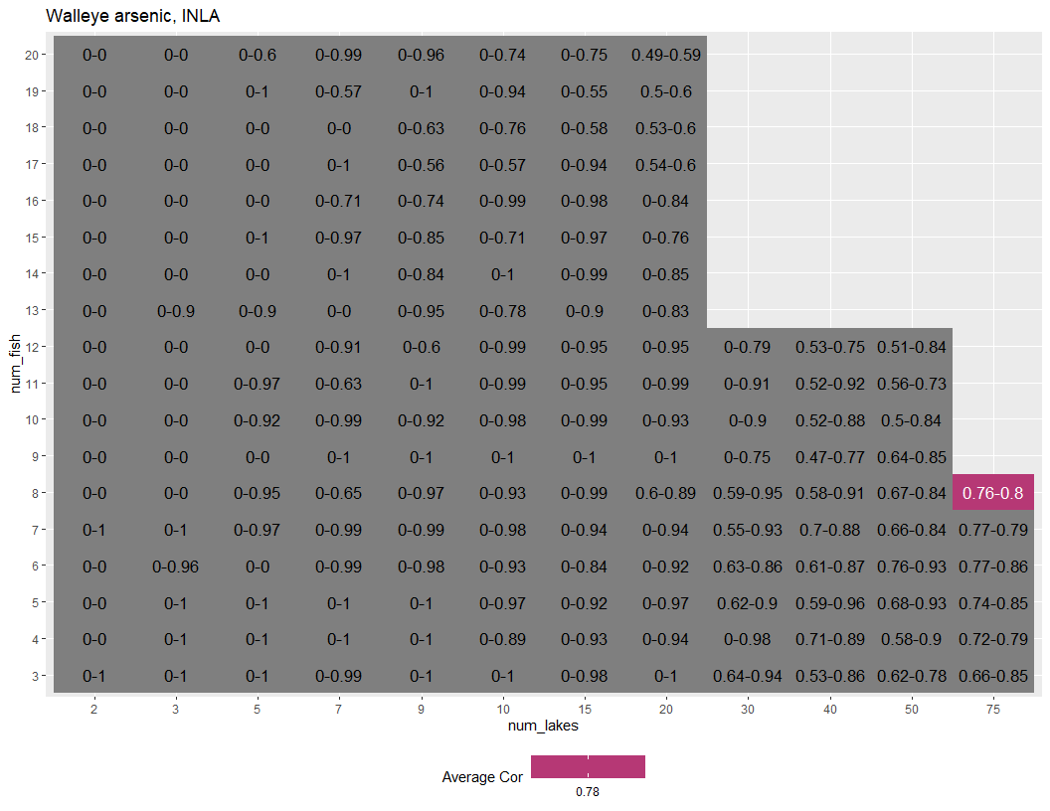

Figure S9: Range of Pearson correlation scores for simulated samplings of Walleye [As] INLA predictions from different lake and fish number combinations. Combinations where there is inadequate performance (min correlation < 0.75 and max correlation <.8) and where performance is unstable when fish or lake numbers are increased are indicated in grey, while remaining cells are colored with light values representing better average model performance.

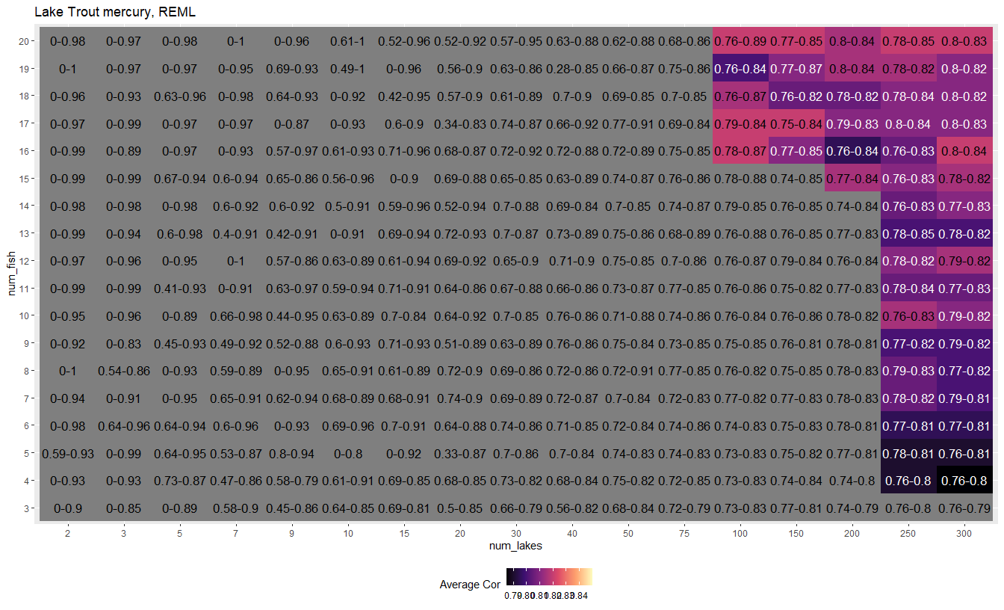

Figure S10: Range of Pearson correlation scores for simulated samplings of Lake Trout [Hg] REML predictions from different lake and fish number combinations. Combinations where there is inadequate performance (min correlation < 0.75 and max correlation <.8) and where performance is unstable when fish or lake numbers are increased are indicated in grey, while remaining cells are colored with light values representing better average model performance.

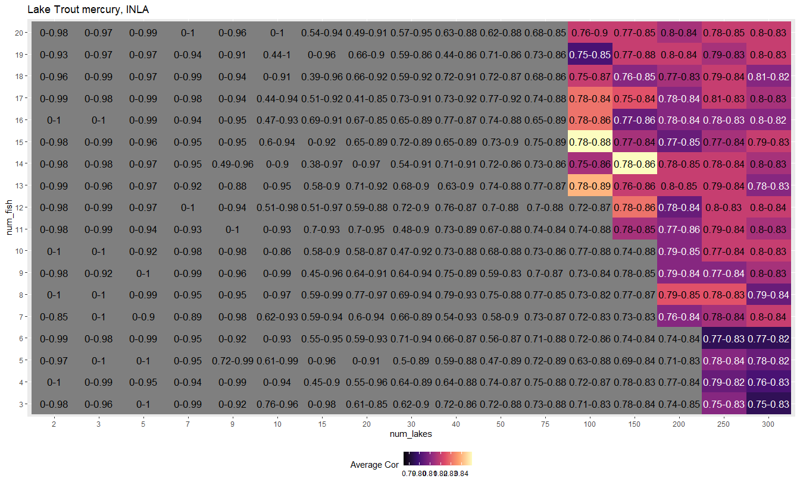

Figure S11: Range of Pearson correlation scores for simulated samplings of Lake Trout [Hg] INLA predictions from different lake and fish number combinations. Combinations where there is inadequate performance (min correlation < 0.75 and max correlation <.8) and where performance is unstable when fish or lake numbers are increased are indicated in grey, while remaining cells are colored with light values representing better average model performance.

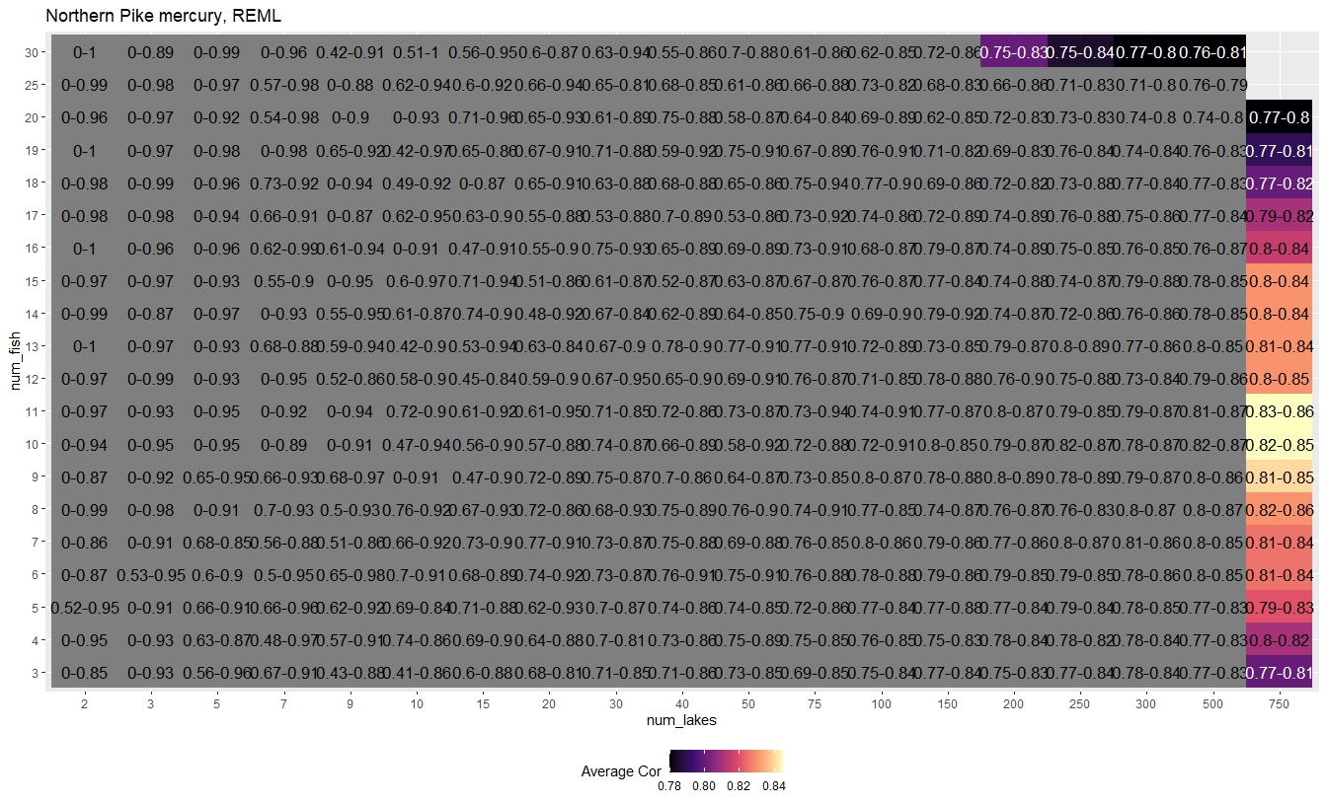

Figure S12: Range of Pearson correlation scores for simulated samplings of Northern Pike [Hg] REML predictions from different lake and fish number combinations. Combinations where there is inadequate performance (min correlation < 0.75 and max correlation <.8) and where performance is unstable when fish or lake numbers are increased are indicated in grey, while remaining cells are colored with light values representing better average model performance.

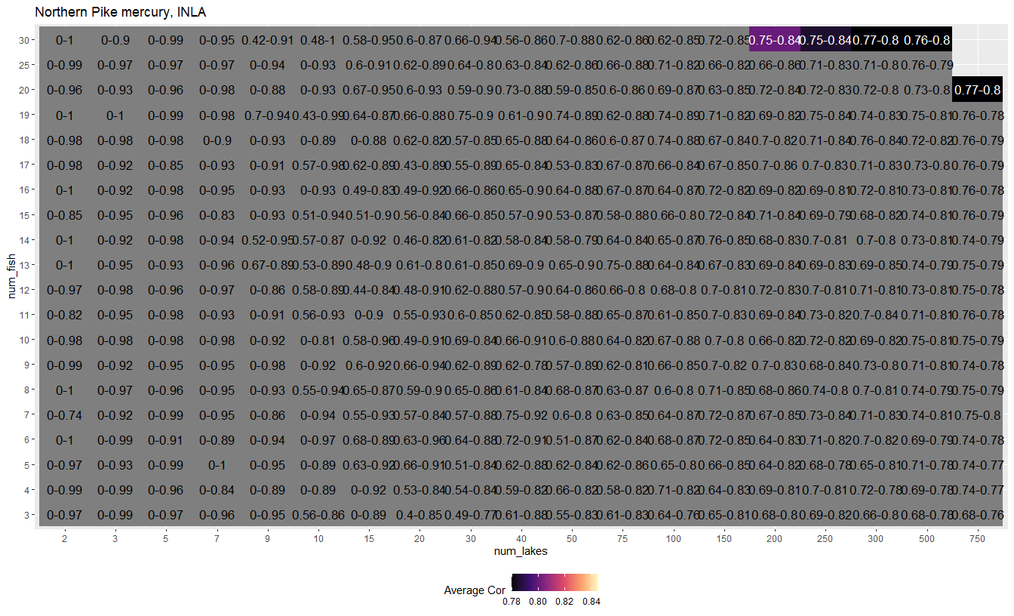

Figure S13: Range of Pearson correlation scores for simulated samplings of Northern Pike [Hg] INLA predictions from different lake and fish number combinations. Combinations where there is inadequate performance (min correlation < 0.75 and max correlation <.8) and where performance is unstable when fish or lake numbers are increased are indicated in grey, while remaining cells are colored with light values representing better average model performance.

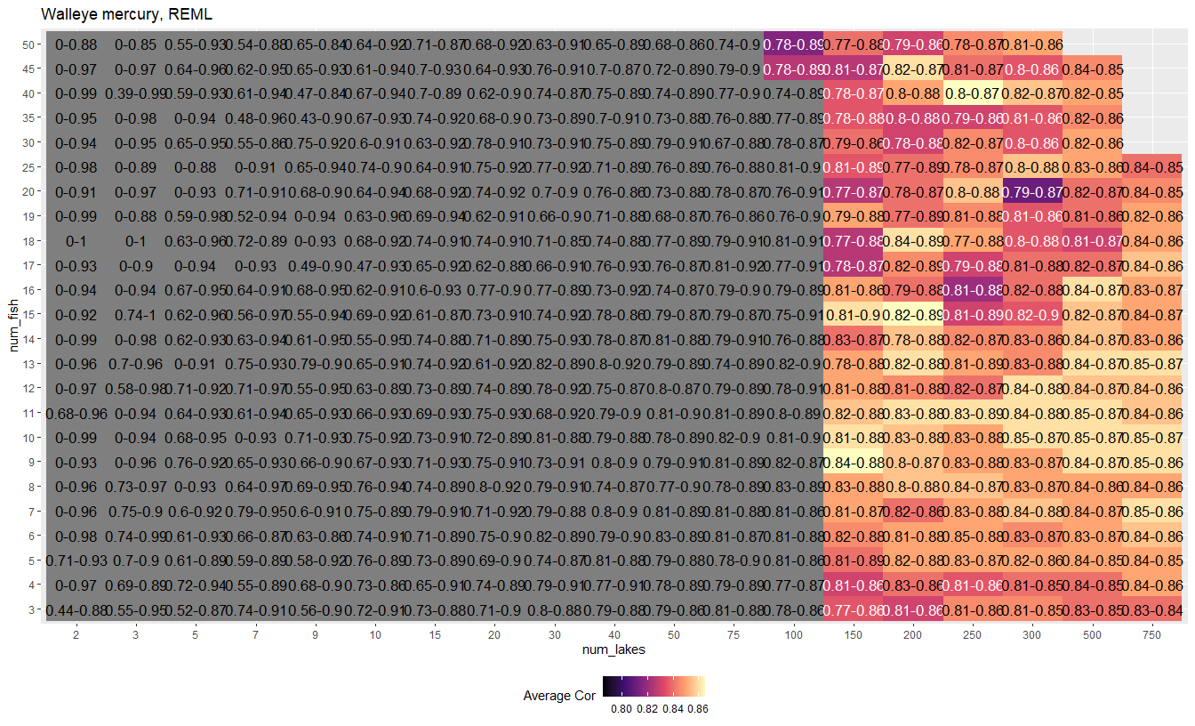

Figure S14: Range of Pearson correlation scores for simulated samplings of Walleye [Hg] REML predictions from different lake and fish number combinations. Combinations where there is inadequate performance (min correlation < 0.75 and max correlation <.8) and where performance is unstable when fish or lake numbers are increased are indicated in grey, while remaining cells are colored with light values representing better average model performance.

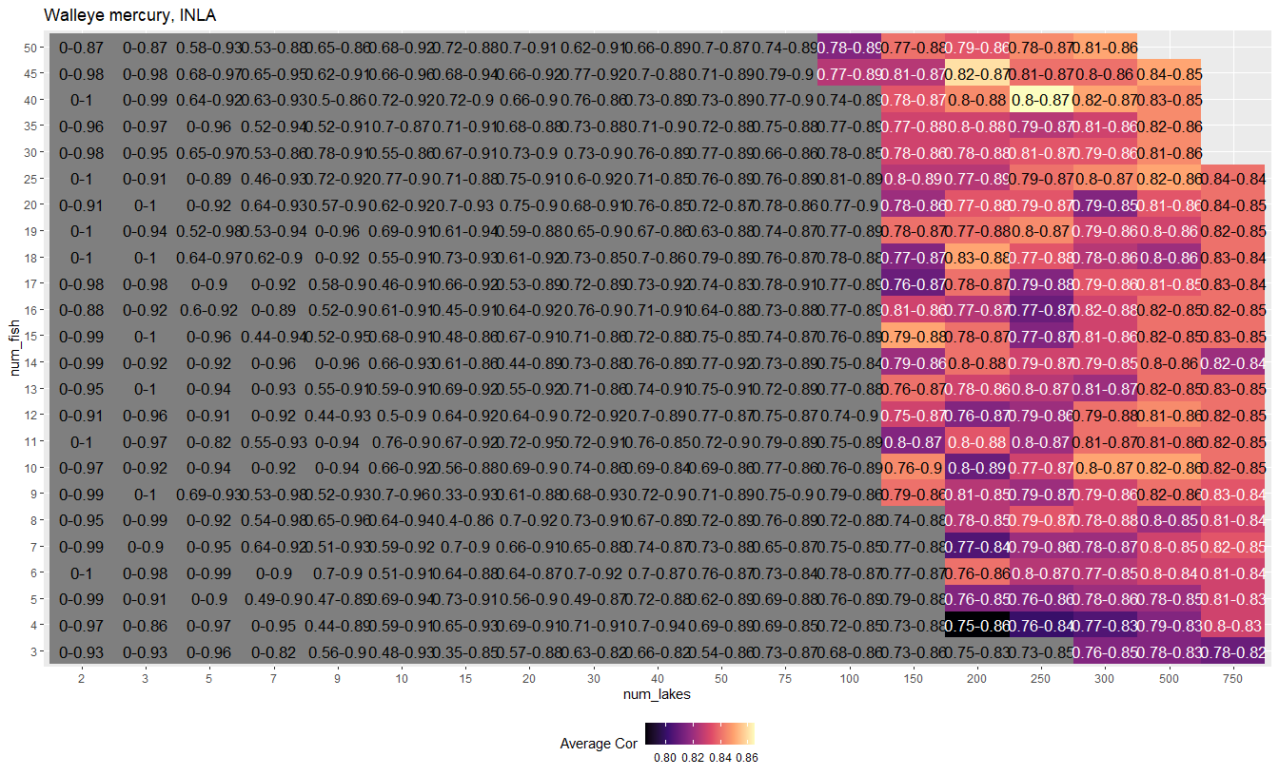

Figure S15: Range of Pearson correlation scores for simulated samplings of Walleye [Hg] INLA predictions from different lake and fish number combinations. Combinations where there is inadequate performance (min correlation < 0.75 and max correlation <.8) and where performance is unstable when fish or lake numbers are increased are indicated in grey, while remaining cells are colored with light values representing better average model performance.